# Proposed Survey

## Demographic Questions (~3 minutes)

What is your age? (Please provide your answer as a whole number, such as

43)

What is your gender identity?

* Female
* Male
* Other

What is your race or origin? Please select one or more of the following options.

* White
* Black, African American, or Negro
* Hispanic, Latino or Spanish origin
* American Indian or Alaska Native
* Asian
* Native Hawaiian or Other Pacific Islander
* Some other race or origin:

What was your total family income last year

* Less than $25,000
* $25,000 to $49,999
* $50,000 to $74,999
* $75,000 to $99,999
* $100,000 to $149,999
* $150,000 or more

What is your highest level of education completed?

* Less than high school degree
* High school degree
* Some college
* Associate degree
* Bachelor's degree
* Master's degree (M.A, M.S., M.B.A., etc.)
* Professional degree (M.D., J.D., etc.)
* Doctoral degree (Ph.D., D. Phill, etc.)

In general, which of the following best describes how you think of yourself?

* Very liberal
* Moderately liberal
* Moderate
* Moderately conservative
* Very conservative

Generally speaking, would you say that most people can be trusted, or that

you can’t be too careful in dealing with people? (Please use a 5-point scale

where 1 means that you can’t be too careful and 5 means that most people

can be trusted.)

* 5: I think most people can be trusted.
* 4
* 3
* 2
* 1: I think you can’t be too careful.

How much do you trust Dr. Anthony Fauci? (Please use a 5-point scale where

1 means that you do not trust him at all and 5 means you trust him a great

deal.)

* 5: I trust Dr. Fauci a great deal.
* 4
* 3
* 2
* 1: I do not trust him at all.

Which of the following is your primary source of access to news? (If there are multiple equally important sources, please pick one of them)

* National mass media
* Local media
* Social media
* Podcasts
* Other news websites NOT affiliated with national or local media
* Clubs or other local communities
* Other
* I do not follow news

When using social media, how often do you post any content (for example,

on Facebook or Twitter)?

* Many times a day
* Daily
* Weekly
* Monthly
* Less than monthly

When using social media, have you ever reported a post, a page, or a user to

the social media platform to be hidden or removed?

* Yes
* No
* I don't know I could do this
* I don't remember

When using social media, have you ever blocked, unfriended, unfollowed or hidden

someone because of the content they have posted?

* Yes
* No
* I don't know I could do this
* I don’t remember

**Covariates that can be beneficial to add -**

1. When viewing news online, how often do you check to see if the source is trustworthy?
2. How often do you search for political/social news online?
3. Do you think that covid is a threat / climate is a threat
4. When using social media, have you ever blocked, unfriended or hidden someone because of the content they have posted? / In general, how often do you get offended or angry when using social media?
5. What is your total family income from last year?
6. In general, do you think of yourself as (liberal, v liberal,...)

## Intro

Have you ever seen a manipulative news article or headline?

* Yes
* No
* Not sure

Do you know how to spot manipulative techniques used in articles or headlines?

* Yes
* No
* Not sure

*Next pages*

What do you think about the following examples? Please rate them using the below scale

*Pre test questions*

## Outcomes Test (pre and post)

### Actual questions

[Post]

1. How manipulative do you find this post?

Not at all Very

1 2 3 4 5 6

2. [Show only if 4-6 selected]:

Which aspect of the post is manipulative? (Please select all that apply)

* Manipulative graph
* Evidence taken out of context
* False comparison
* Misleading anecdote
* Other:

3. Behavior questions

* Would you like to share this post on social media?

Definitely not Definitely yes

1 2 3 4 5 6

* Would you want to talk to others about this information offline?

Definitely not Definitely yes

1 2 3 4 5 6

*(Check in pilot how many people share / report)*

~~Ask about problem of misinformation (manipulative) as part of demographic and very end~~

* ~~How would someone like you feel if the research team re-shared this post on their social media accounts?~~
* ~~Would you like to report this post to have it removed?~~
* ~~Would you stop following an account that posted content like this?~~
* ~~Would you want your friends, family, or acquaintances to know this information?~~
* ~~Is it worth our fact checker’s time to check this post?~~
* ~~Would you like to read more to find out the trustworthiness of this post?~~

~~Definitely not Definitely yes~~

~~1 2 3 4 5 6~~

* ~~Maybe replace second one with a good way of asking if you would want to fact check? E.g.~~

### Discussion

8 questions each, 2 true, 2 for each tactic

Questions:

1. How misleading is the content? (1 - not misleading at all, 6 - very misleading)

* Very manipulative
* Manipulative
* Fairly manipulative
* Slightly manipulative
* Not manipulative
  1. If misleading, what aspect of the content is misleading? *(should we ask these after they have gone through the whole set of content?)*
     1. Misleading graphs
     2. Cherry picked statistics
     3. Out of context
     4. Other?

1. Would you share this post on social media?
2. What other actions would you want to take immediately after reading the post?
   1. Comment
   2. Research
   3. Report
   4. Nothing

Which of the following actions would you take after seeing this post?

* + - * Read the entire article
      * Read more on the topic
      * Fact check the post
      * Share it
      * Show it to someone
      * Report
      * Follow the suggested advice
      * Comment
      * Nothing
      * Other

Which of the following actions would you take after seeing this post? (Please select all that applies)

* Read more on the topic
* Share it to inform others
* Comment to express disbelief
* Like it
* Report it
* Nothing
* Other

What would be your first action after seeing this post? (Same options as above)

How likely are you to share this post on social media?

* Definitely
* Very Probably
* Probably
* Possibly
* Probably Not
* Definitely Not

## Tactics Course

### [Intro & Graphs]

There are **over 26 different tactics** used to create manipulative content!

We’ll now show you how three of them look.

*Next page*

💬 Do you know how to finish this saying:

As the old saying goes: “A picture can tell

* an image
* colors and shapes
* a thousand words
* no words

*Next page*

That’s correct! / That’s actually not quite right. A picture can tell a thousand words, and that’s also true for graphs and diagrams. 📈📊 These can make information look more official.

⚠️ The danger is that graphs can be easily presented to be manipulative.

🧐 Can you think of any ways to make a graph manipulative? Select all the options below that you think would make a graph manipulative

* Use incorrect numbers
* Draw the graph incorrectly
* Change an axis
* Truncate an axis
* Use a confusing graph type
* Add distracting elements
* Omit the labels
* Add unnecessary images
* Use confusing colors

*Next page*

You are right! And in fact, all of the options listed earlier include manipulation tactics.

Here is an example of truncating the vertical axis

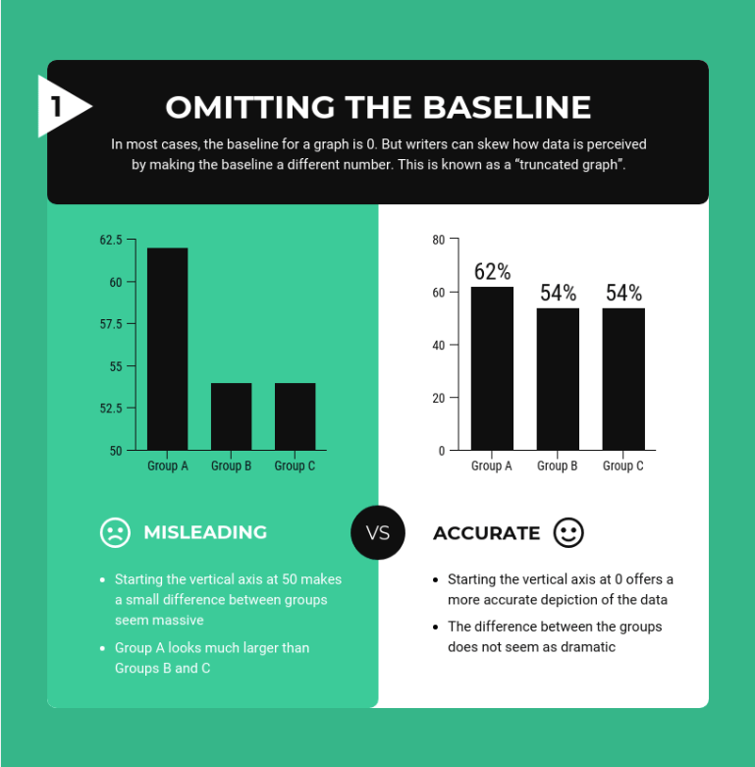

If the vertical axis doesn’t start at zero, small differences may seem much bigger.

Stretching out the vertical axis can have the opposite effect, as you can see it below:

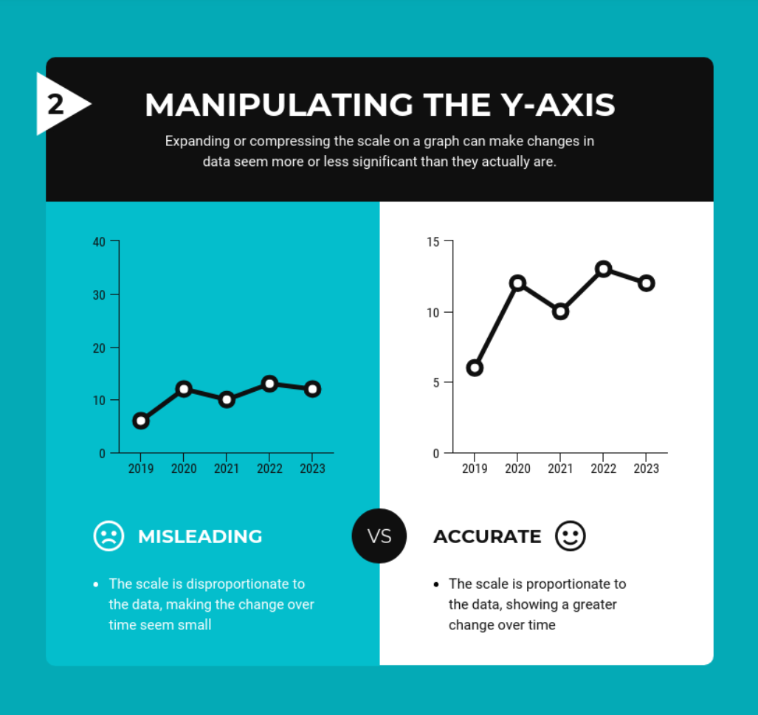

Using the wrong kind of graph can be just as misleading:

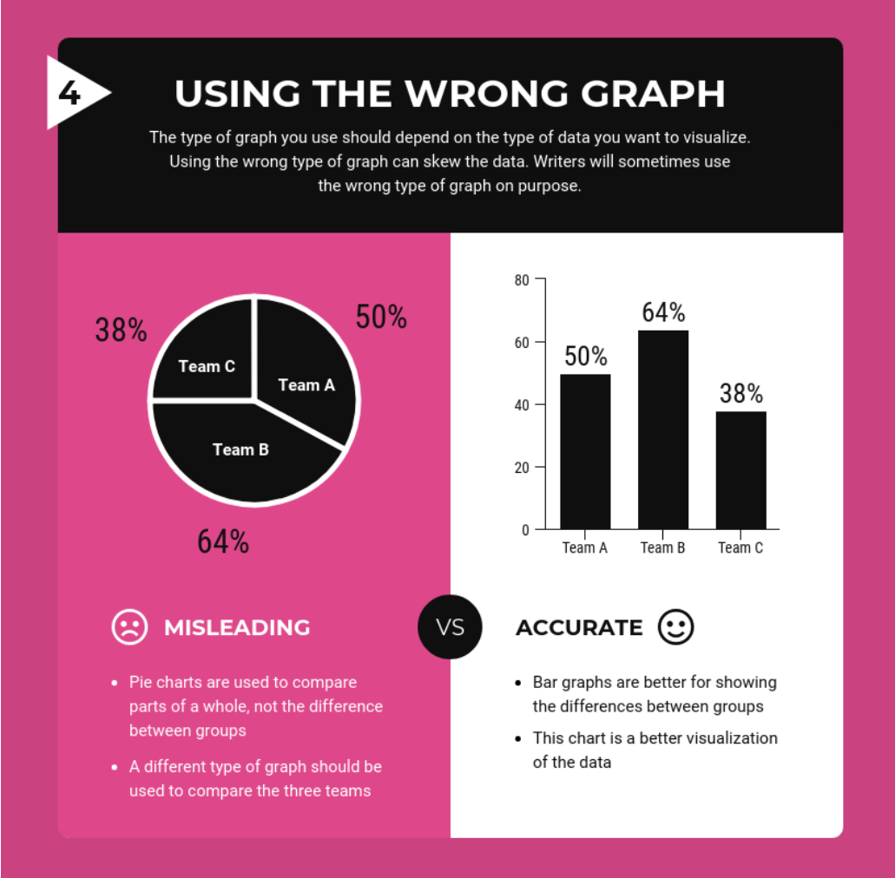

Let’s look at a real example. What do you think about the following graph?

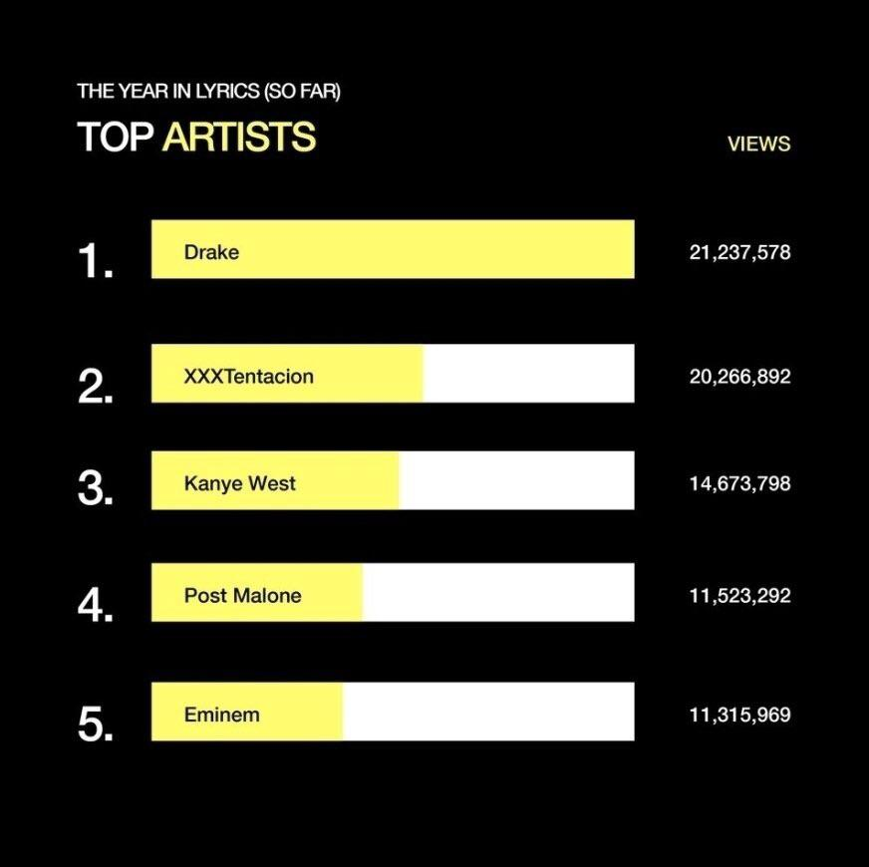

* Drake is so much better than everyone else
* The bars seem a bit off

*Next Page*

Let’s take a more careful look / That’s right! Drake doesn’t look that far ahead of the competition if the bars are plotted correctly.

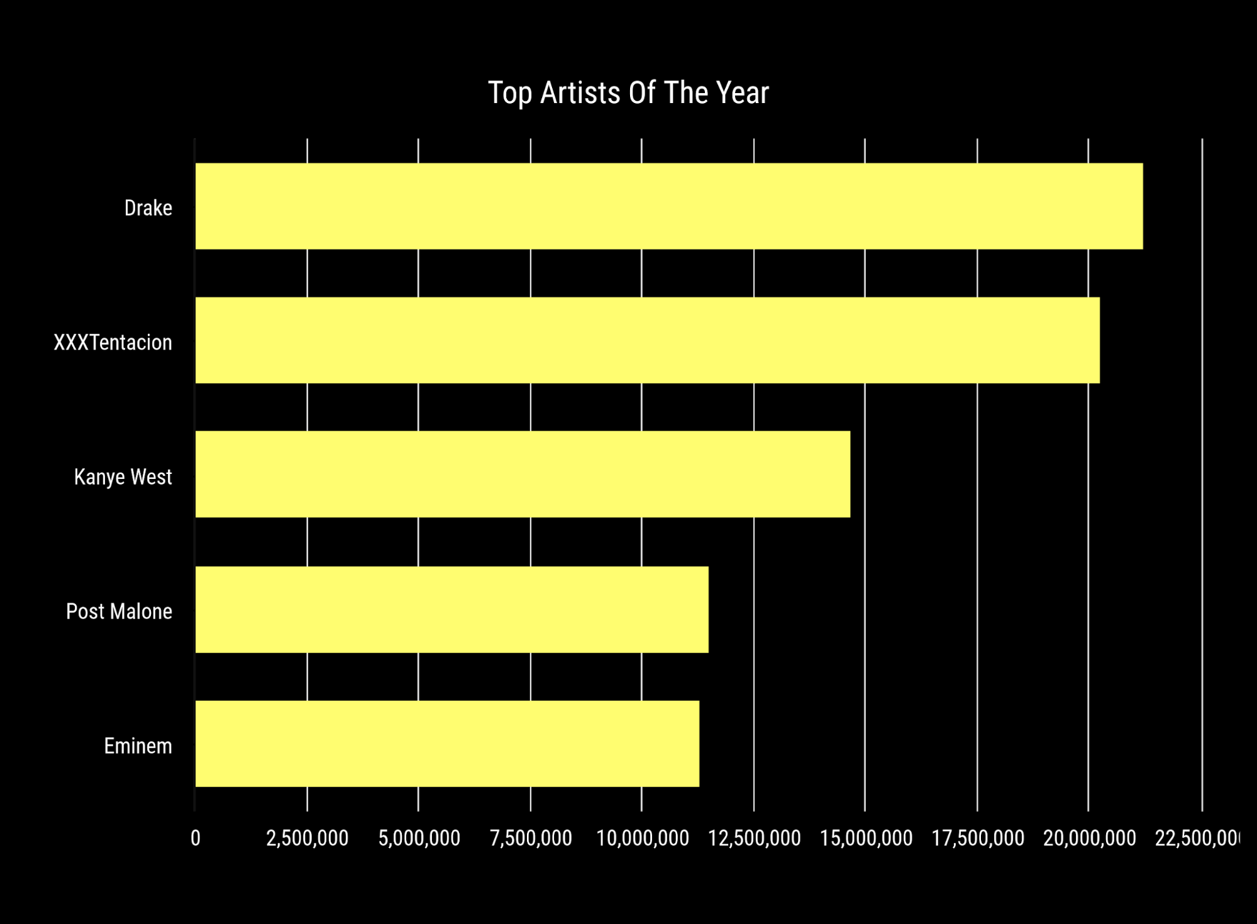

👀 When confronted with a graph or diagram on social media, be sure to look it over carefully and check where the data comes from.

You have mastered the tactic of manipulating graphs and diagrams!

### [Anecdotes]

💬 Have you ever had a friend rave to you about something like a restaurant or a movie — only to be disappointed when you tried it yourself?

* Yes
* No
* I’m not sure

*Next page*

When someone tells you about their experience with something, that story is called an anecdote, and they aren’t always reliable.

⁉️ How does that work?

⚠️ The danger of anecdotes is that they assume what’s true for one person should be true for everyone. Here’s an example:

Suppose a friend told you: “My cousin is a really fast sprinter, and only buys shoes with thin soles. So if you want to run faster, you should buy shoes with thin soles, too!”

🧐 What do you think about this example?

* This is great advice!
* This anecdote could be misleading

*Next Page*

[Maybe.] / [Yes!] It’s possible that there’s more information about the cousin that we could be missing. Maybe their cousin is a fast sprinter because they do a lot of training.

⚠️ This means that we need to be careful about anecdotes because they could lead us to the wrong conclusion. In fact, using anecdotes is a common tactic to persuade and manipulate.

🍒 Anecdotes are often cherry-picked because something unusual happened. You don’t hear all the times that something didn’t work, because those stories aren’t as interesting.

🧠 Humans are also more likely to remember personal stories, even if they aren’t as accurate.

Here are some other examples. Which of these examples do you think could be using anecdotes to manipulate their audience?

* An advertisement where a celebrity tells you about their great experience with a new product
* A politician telling you about a conversation they had with a voter
* A friend telling you about how much money they made investing in a new business

*Next Page*

All of these could be examples of using anecdotes for manipulation! None of these examples are giving you information that something is true all the time. They’re telling you a story about one person’s specific experience.

👀 When confronted with an anecdote, take a moment to reflect on whether there may be reasons that it doesn’t apply to you.

You have mastered the tactic of anecdotes!

Additional Headlines for pre/post test (didn’t use these):

I went to the gas station an hour ago and saw a huge line of cars waiting. Demand for gas has been increasing, which is why gas prices are so high now.

My grandmother smoked a pack of cigarettes a day and ate whatever she wanted. She outlived my grandfather who restricted himself to a vegetarian diet. This shows that the secret to longevity is to live freely, doing what you enjoy.

### [False comparisons]

💬 Do you know how to finish this phrase:

“Stop comparing apples to…” ?

* apples
* cars
* pies
* trees
* oranges

*Next page*

That’s correct! / That’s actually not quite right. The phrase, comparing apples to oranges, refers to comparing two things, food related or otherwise, that share obvious common characteristics, while being ultimately different.

In the case of apples and oranges, it is obvious that while they are both fruits, they are quite different in many aspects.

⚠️ The danger is when comparisons are made between more complex things in order to manipulate the reader to jump into conclusions.

🧐 Can you think of comparisons that could be used to manipulate? Select the pairs of things from the list below that you think could be used to make manipulative conclusions

* Two groups of people on the same diet
* Addictions to alcohol or to shopping
* Attending public school today or 50 years ago
* Two patients with the same disease
* Running the country or running a company
* Buying a lottery ticket or buying a stock
* Two patients having fever

*Next page*

You are right! And in fact, all of the options listed earlier refer to things that are similar in some aspects while being not exactly same in other regards. Such pairs of things can be used to manipulate by making a misleading or false comparison.

Here is an example of this:

“Car insurance companies reward good behavior: no claims = better rates. Why not have health insurance companies reward good behavior too?”

Car insurance and health insurance companies both provide insurance that can save you large amounts of $$$ in case things go wrong. However, there are important differences between the two. For example, medical insurance covers “maintenance” like regular checkups and preventative care. Additionally, costly medical concerns often arise due to causes beyond the “fault” of the individual.

This is to show that examples like the above are complex cases. Simplifying them using a false comparison disregards important details and can be used to manipulate.

Let’s see another example:

“Running the country is no different from running a business. It’s irresponsible to increase national debt.”

What do you think about the above statement?

* It is not manipulative, no complexities are omitted
* It is manipulative, complexities are omitted

*Next page*

That’s correct / not quite. Both the Government and companies have balance sheets, revenues and expenses. However, the goal of a company is to maximize profits, which is not the primary objective of the Government. Instead, the Government has significantly more complex objectives.

👀 When confronted with a simple looking comparison, take a moment to think carefully and ask whether any complexities have been omitted.

You have mastered the tactic of false comparisons!



Headlines for pre/post test:

This slot machine is the one! Investing in the stock market is really no different from buying a lottery ticket or playing a slot machine, it’s all just a gamle on some random choice. Try this machine to have the best odds!

Trying to quit smoking? Try this meditation technique! It’s the BEST, it has helped THOUSANDS of people overcome their addiction to video games.

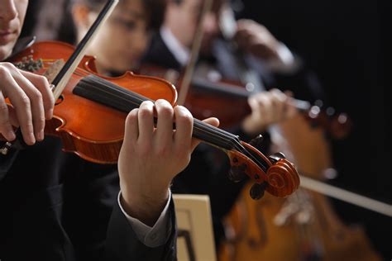

Studies have shown that students who attend schools with expansive music programs tend to perform much higher on standardized testing. If your child is struggling with grades, this is the music program they need. It’s guaranteed to work!

### Drafts

#### Red Herring (Quentin)

~~The red herring fallacy is mostly used in conversation with the public to distract them or to change the subject to escape from a difficult situation. For politicians, the red herring fallacy is a trick which they use to dodge awkward questions asked in an argument or conference. They start talking about some unrelated topic to distract the public.~~

~~The first step to responding to red herring fallacies is recognizing them in the wild. Here are a few things to keep in mind to detect red herrings:~~

~~Does the statement/argument change the point of the conversation from the original topic?~~

~~Is the given reason actually a justification for the presented view, or is it tangential and not related?~~

~~Does the given argument actually refute what it’s intended to refute, or something else?~~

~~As is the case with most fallacies, the best strategy is to point out why the particular statement/argument is irrelevant to the context at hand. To be more precise, you should show why the statement is irrelevant and how it is being used to change the topic of conversation.~~

#### Misleading Graphs and Diagrams

Version 1

As the old saying goes: “A picture can tell a thousand words.” 🖼

⚠️This is especially true when it comes to misinformation.

📈📊Graphs and diagrams often make information look more official. The danger is that they can easily be misleading, especially if they use cherry-picked statistics or wrong sizes to support one kind of story without providing all of the data and context.

Let’s look at some techniques people use to make their graphs misleading:







Let’s look at a real example. What do you notice about the following graph?



1. Drake is so much better than everyone else
2. Wait, the bars seem a bit off

That’s right! Drake doesn’t look that far ahead of the competition if you plot the bar chart correctly.



💪 When confronted with a graph or diagram on social media, be sure to look it over carefully and check where the data comes from.

Misleading graphs (<https://www.statisticshowto.com/probability-and-statistics/descriptive-statistics/misleading-graphs/>)

<https://en.wikipedia.org/wiki/Misleading_graph>

https://venngage.com/blog/misleading-graphs/

## Control text

### [Intro & Quantity]

There are lots of different ways that we impact sleep and sleep impacts our lives.

We’ll now show you three of them.

*Next page*

💬 Do you know how to finish this saying:

“Got out on the wrong side of the…”

* chair
* bed
* couch
* train
* plane

*Next page*

[That’s correct!] / [That’s actually not quite right]. The phrase “got out on the wrong side of the bed” describes someone who’s in a bad mood all day. There are many reasons that might happen. One common cause is not getting enough sleep.

⚠️Insufficient sleep can affect us in many different ways. Here are the results from a survey where Americans identified how they were impacted by too little sleep:

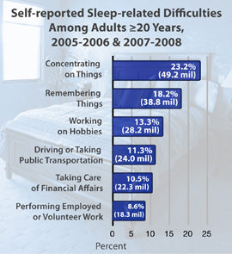

🏥In fact, not getting enough sleep can also impact our health. Here’s a list of different health issues. Which of these do you think are related to not getting enough sleep?

* Heart Attack
* Stroke
* Obesity
* Dementia
* Cancer

*Next page*

That’s right! In fact, all of these health issues are somehow related to how much sleep we get. Every major system and organ in our body is impacted when we don’t get enough sleep.

💤Most major health organizations suggest that we get at least 7 hours of sleep per night. How much sleep you need, however, varies depending on who you are. Children, for example, typically need more sleep than their parents.

🛏There’s a difference between our sleep duration (how long we sleep for) and sleep opportunity (how long we spend in bed). If someone struggles to fall asleep, or wakes up during the night, they may need to spend more time in bed to get enough sleep.

Here’s an example. Suppose a friend told you: “I’m really health conscious. I eat well, exercise regularly, and make sure I spend 7 hours in bed every night.”

🧐What do you think about this example?

* My friend is very healthy, and is definitely getting enough sleep.
* My friend may be able to improve their health if they get more sleep.

*Next page*

[That’s actually not quite right.] / [That’s correct!] If your friend is just spending 7 hours in bed each night, then they’re probably getting less than 7 hours of sleep. This means that they’re getting less sleep than health organizations suggest.

🧠 Reflect on how much sleep you get every night, and whether you might benefit from getting more or spending more time in bed.

You’ve learned all about getting enough sleep!

### [Caffeine]

💬 Do you know how to finish this phrase:

“Wake up and smell the…” ?

* morning air
* flowers
* coffee
* bacon
* pancakes

*Next page*

[That’s correct!] / [That’s actually not quite right]. The phrase “wake up and smell the coffee” means that someone has finally realized the truth about what’s going on. It refers to the large number of people who drink coffee in the morning to wake up.

☕️The caffeine in coffee can block some of the chemicals in our brains that make us feel sleepy. This can trick our bodies into feeling alert and awake.

⚠️ While there are times we may want to feel awake, one danger of coffee is that it can prevent us from getting a good night’s sleep. This also isn’t just true of coffee, many things can contain caffeine.

🧐 Can you think of other products that could contain caffeine? Select any of the food or drinks from the list below where caffeine might be present.

* Tea
* Energy drinks
* Decaffeinated coffee
* Ice cream
* Dark chocolate

*Next page*

That’s right! In fact, all of the options listed earlier could potentially contain caffeine – including decaffeinated coffee. Although decaffeinated coffee contains less caffeine than a regular cup, it can still have 3-10% of a regular dose.

🕐Caffeine can also stay in our bodies longer than we expect. It can take as much as 7 hours for our bodies to remove half the caffeine we consume from our brain.

🎂Aging can also alter how fast we process caffeine. The older we are, the longer it can take our brain and body to remove it.

Here’s an example. Suppose a friend told you: “I love coffee, but I can’t drink it too close to bed. I have my last cup at about 5pm as soon as I get home from work. That way, it won’t interfere with my sleep.”

🧐What do you think about this example?

* My friend will definitely sleep well using this schedule.
* My friend may still struggle to sleep because of caffeine.

*Next page*

[That’s correct!] / [That’s actually not quite right]. Even if they drink their last cup of coffee at 5pm, their body may not have removed even half of it by midnight! Even then, they would still be impacted by the other half, making it difficult to sleep.

🧠 When choosing to eat or drink something which contains caffeine, think carefully about what time it is and what time you plan to go to bed.

You’ve learned all about caffeine!

### [Schedules]

💬 Have you ever noticed that you tend to sleep more on your day off – like a public holiday or the weekend?

* Yes
* No
* I’m not sure

*Next page*

Many people find that their regular week of work or study is tiring. They play “catch up” on the weekend by sleeping in.

🗓Getting enough and catching up on lost sleep is important. But many people will find that they feel better rested if they wake up and go to sleep at the same time each day.

🥱Our bodies can struggle to adapt to a change in sleep schedule. Sleeping later on weekends usually won’t fully make up for too little sleep during the week. It can also make it more difficult to get up on Monday.

🧐 Here are some examples of regular, 9-hour sleep schedules. Which of these examples do you think could help promote a healthy sleep habit?

* Regularly going to bed at 8pm and getting up at 5am
* Regularly going to bed at 10pm and getting up at 7am
* Regularly going to bed at 12am and getting up at 9am

*Next page*

All of these could help promote a healthy sleep habit! The important thing is picking a schedule and sticking to it consistently. When each person should go to bed depends on their own schedule, and when they feel tired during the day.

⏰There are several strategies you can use to help manage a regular sleep schedule. One useful tip is to set an alarm clock. Alarms help us wake up in the morning, but we can use them to remind us to go to bed on time as well!

🚿Another helpful strategy is setting a regular bedtime routine. This could involve taking a shower, tidying your bedroom, or reading a book.

Let’s look at an example. Suppose a friend told you: “I’m very particular about my sleep, and I keep the same schedule every week. I go to bed at 9pm every night on the dot. The only exception is Wednesdays when I catch up with friends. I go to bed at 10pm.”

🧐What do you think about this example?

* This schedule is the same every week. My friend must be sleeping well.
* Going to bed later on Wednesday’s makes this schedule inconsistent. This may impact my friend’s sleep.

*Next page*

[That’s actually not quite right.] / [That’s right!] Having a regular sleep schedule means doing the same thing every day, not every week. That’s the consistency that matters.

🧠 When planning your day, think about if you could wake up and go to bed at the same time as yesterday and the day before.

You’ve learned all about sleep schedules!

## Sources

Survey question format examples: <https://www.extension.iastate.edu/Documents/ANR/LikertScaleExamplesforSurveys.pdf>

False comparison examples: <https://examples.yourdictionary.com/false-analogy-examples.html>

Not actually used, just for “fun”:

False comparisons, great video: <https://www.youtube.com/watch?v=XZ-qspBsbqA>

False comparisons, wars: <https://www.ff.org/false-analogies-the-heart-of-fake-foreign-policy-news/>

False comparisons, not the best examples: <https://www.softschools.com/examples/grammar/false_analogy_examples/178/>

Simpler example “intervention”:

<https://www.nbcnews.com/better/lifestyle/don-t-be-fooled-fake-stories-cloned-news-websites-used-ncna1063911>

Some fun facts:

<https://www.buzzfeednews.com/article/craigsilverman/facebook-fake-news-hits-2018>

Source for control text:

[**Why We Sleep: Responses to questions from readers**](https://sleepdiplomat.wordpress.com/2019/12/19/why-we-sleep-responses-to-questions-from-readers/)